Josh Millikan

Paul Addison

SDEV 140

12/12/21

JOSH’S CURRENCY CONVERTER USER GUIDE

In this guide, we show how to open and operate the currency converter properly. Looke below to see instructions.

Step 1) Open up the .py file in your python IDLE

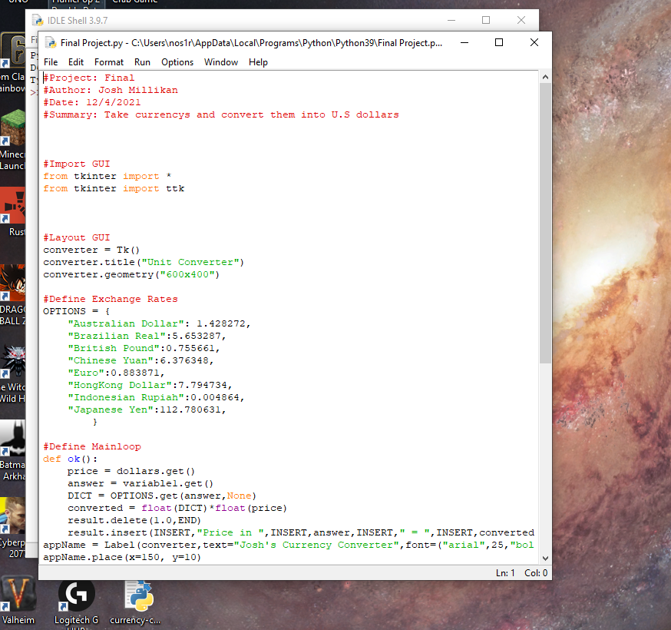

Step 2) After opening the IDLE run the module. It will be located on the top bar of the program.

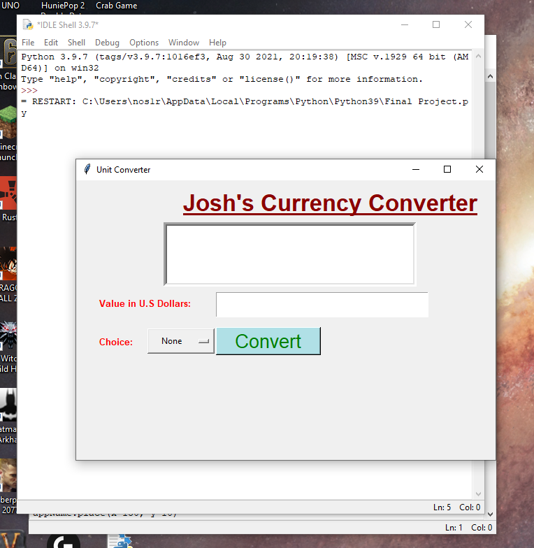

Step 3) After running the module a popup GUI should appear on the desktop of your PC. You will type your amount of money you would like to convert and then you press the drop down box to choose what type of currency you are converting from in USD.

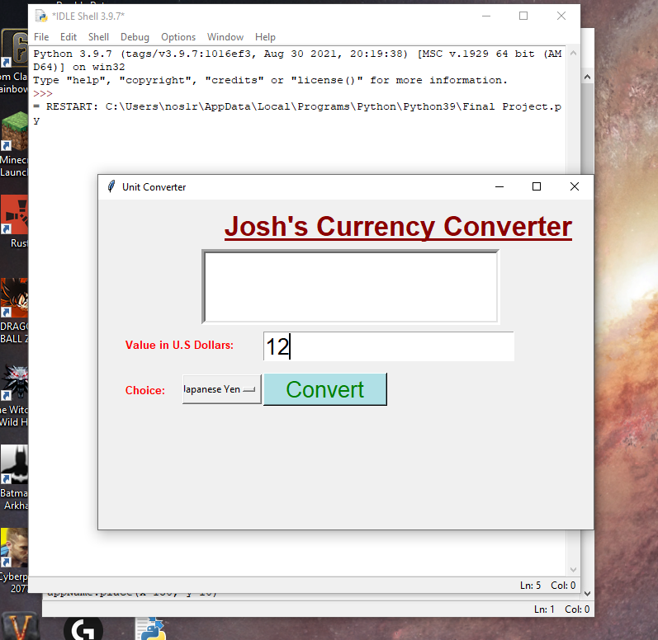

Step 4) After choosing those options press the convert button. Up above you should receive a message telling you how much USD converted to said converted amount of money.

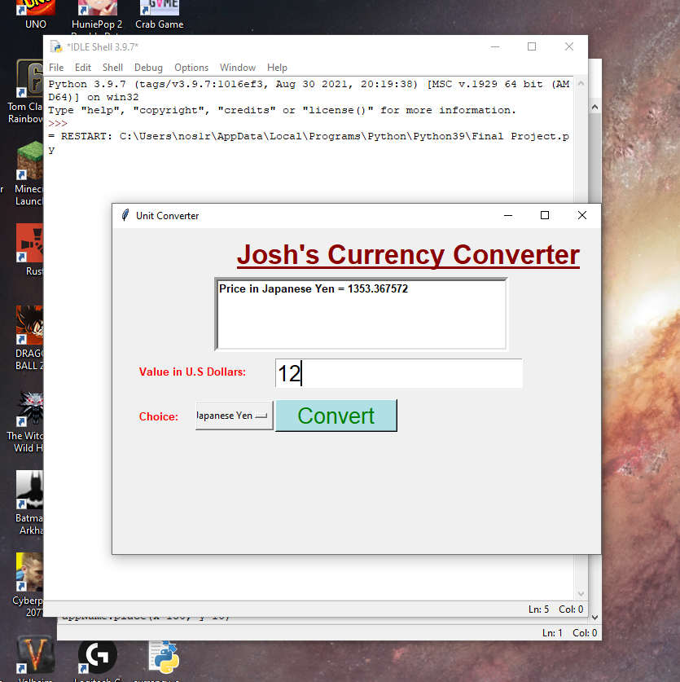

After following the steps above you should be able to understand how to operate the currency converter.